Roll No: 2003055
SET - A
Lab Final
Lab Task Q[1]
Question:

4 bit ALU
Solution (Code/Add all circuits diagrams):
ORR:
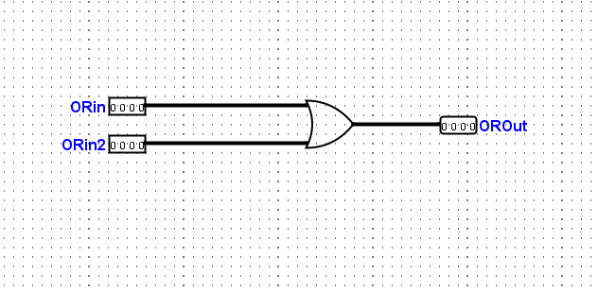
ADD:
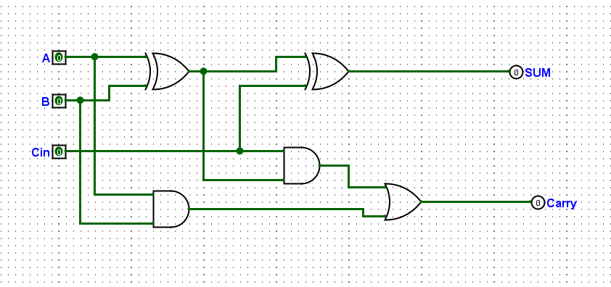
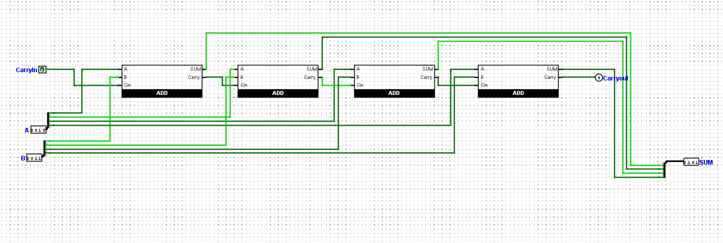
LEFT SHIFT:
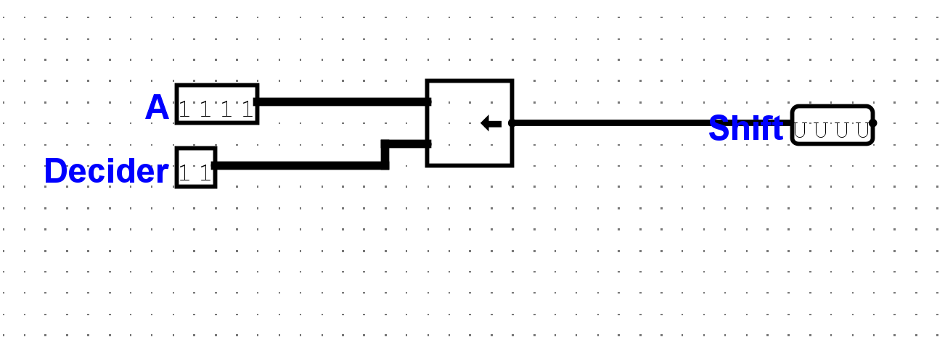
NOT:
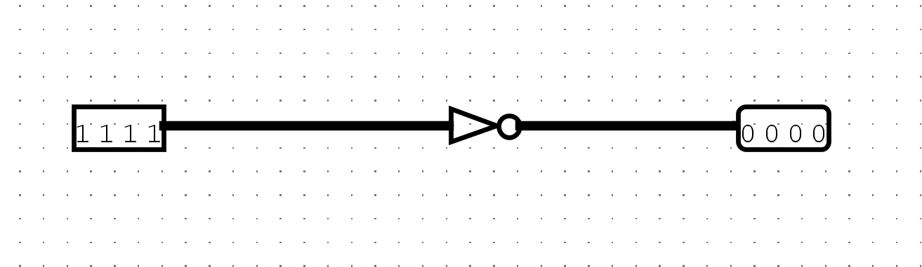
ALU:
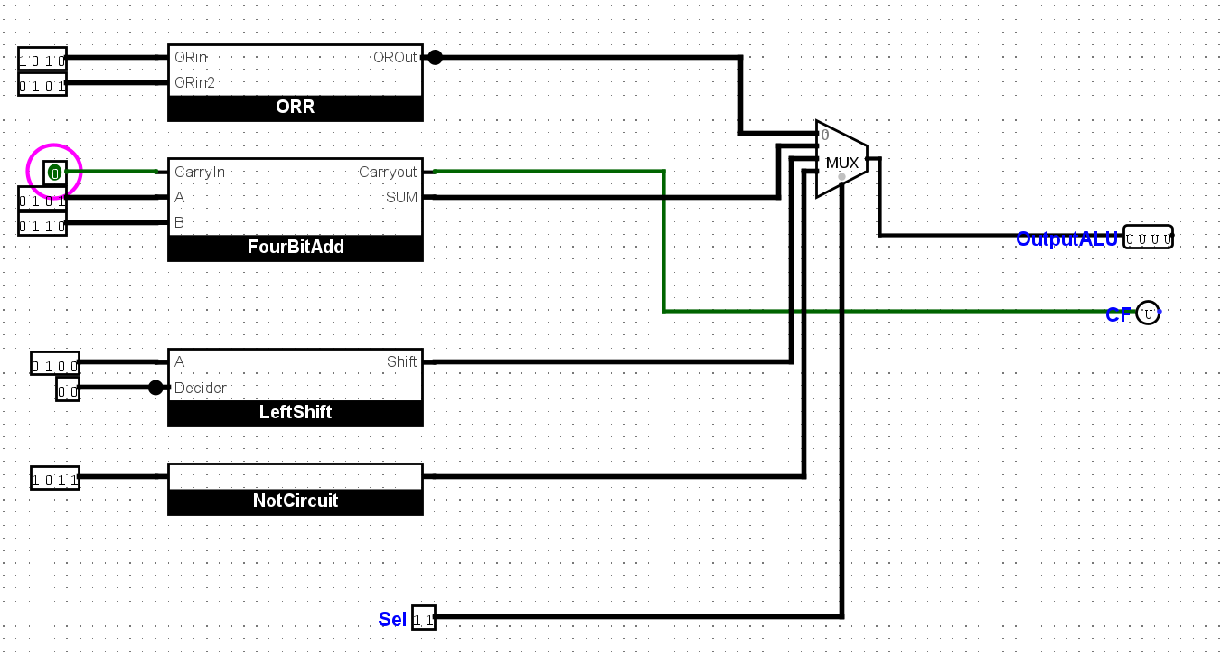

Output/Simulation Result (Screenshot/SnapShot):

Lab Task Q[2]
Question:
Left rotate operation on a 4 bit operand

Solution (Code/Add all circuits diagrams):
module left_rotate_4bit (
input [3:0] A, // 4-bit input operand
output [3:0] Y // 4-bit rotated output
);

assign Y = {A[2:0], A[3]}; // Left rotate operation

endmodule

testbench:
`timescale 1ns/1ns

module tb_left_rotate_4bit;

reg [3:0] A; // 4-bit input operand
wire [3:0] Y; // 4-bit rotated output

left_rotate_4bit uut (
.A(A),
.Y(Y)
);

initial begin
$dumpfile("test.vcd");
$dumpvars(0, tb_left_rotate_4bit);

A = 4'b1001; #10; // Test with input 1001
A = 4'b1100; #10; // Test with input 1100
A = 4'b0111; #10; // Test with input 0111
A = 4'b0001; #10; // Test with input 0001
$finish;
end

initial begin
$monitor("Time = %0t | A = %b | Y = %b", $time, A, Y);
end

endmodule

Output/Simulation Result (Screenshot/SnapShot):
Terminal:
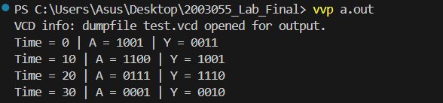
gtkWave:
